**LAB1**

**LAB2**

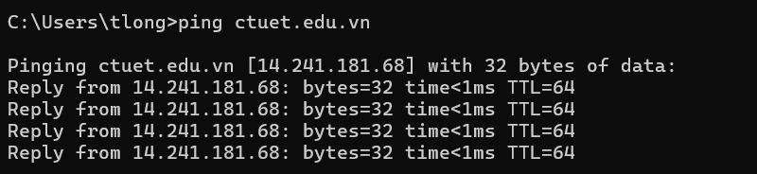

Vùng IP: 172.16.1.0/16



